39.62: a) 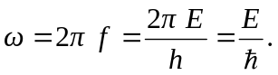
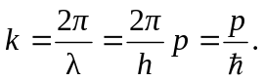
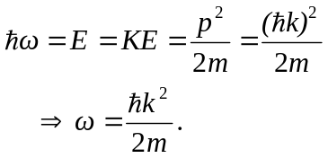
b) From Problem 39.61 the time-dependent Schrödinger’s equation is 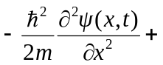
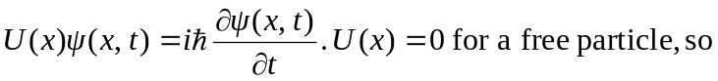
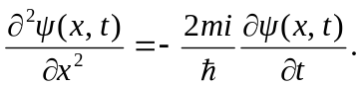
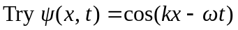
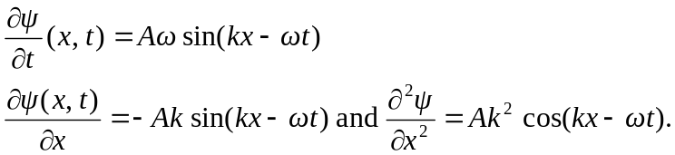
Putting this into the Schrödinger’s equation, 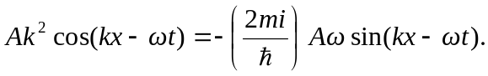
This is not generally true for all 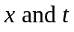 so is not a solution.
c) 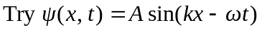
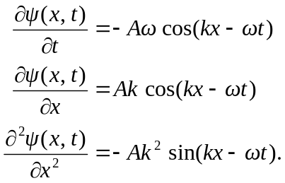
Again, 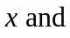
so is not a good solution.
d)
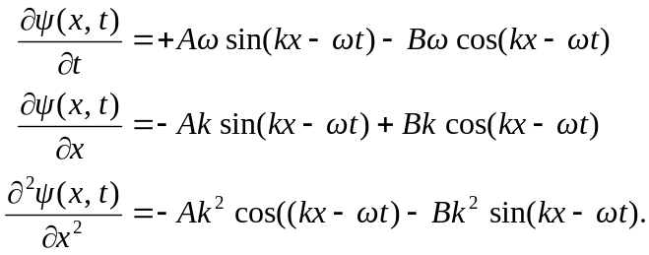
Putting this into the Schrödinger’s equation,

Recall that 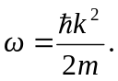 Collect sin and cos terms.
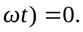 This is only true if B = iA.

